CHUKA  UNIVERSITY
FACULTY OF SCIENCE, ENGINEERING AND TECHNOLOGY
DEPARTMENT OF COMPUTER SCIENCE
AHMED ABDUL HAK
EB1/61368/22
COSC 482
COMPUTER SYSTEM PROJECT 1
BERNARD ONG'ERA OSERO

Table of contents

Contents
Table of contents 2
List of figures 4
List of tables 5
Design and Implementation of NduthiRide: A Smart Ride and Parcel Delivery System Using Angular, NestJS, and PostgreSQL 6
Abstract 6
Chapter One: Introduction 7
1.1 Background to the Study 7
1.2 Problem Statement 8
1.3 Objectives of the Project 9
1.3.1 General Objective 9
1.3.2 Specific Objectives 9
1.4 Scope and Limitations 10
1.4.1 Scope 10
1.4.2 Limitations 11
1.5 Significance of the Study 11
Chapter Two: Literature Review 13
2.1 Review of Existing Ride-Hailing & Parcel Systems and Gap Analysis 13
2.2 Theoretical Framework: Agile Software Development and System Usability 14
2.3 Review of Key Technologies 15
2.3.1 Frontend: Angular with Tailwind CSS for Responsive UI Development 15
2.3.2 Backend: NestJS for Modular and Scalable API Development 16
2.3.3 Database: PostgreSQL with Prisma ORM for Type-Safe Data Access 17
2.3.4 Payment Integration: Safaricom M-Pesa Daraja API 17
Chapter Three: Methodology and System Analysis 19
3.0 Introduction 19
3.1 Project Methodology 19
3.2 Scrum Application and Phasing 19
3.3 Data Collection and Validation Techniques 20
3.4 Resources and Budget 21
3.5 Requirements Analysis 22
3.5.1 Functional Requirements (FRs) 22
3.5.2 Non-Functional Requirements (NFRs) 23
3.6 Technology Stack Justification Synthesis 24
Chapter Four: System Design 26
4.0 Introduction 26
4.1 System Architecture Overview 27
4.2 Database Design: The Hybrid Operational-Transactional Model 28
4.2.1 Core Entity-Relationship Structure 28
4.2.2 Supporting Real-time and Analytical Needs 30
4.3 Module Design Details 37
4.4 Scalability and Future Readiness Design 39
Chapter Five: Expected Outcomes, Project Schedule, and Conclusion 40
5.0 Expected Outcomes and Deliverables 40
5.1 Software Deliverables (Working System 40
5.2 Academic and Documentation Deliverables 40
5.3 Project Schedule 41
5.4 Conclusion and Future Work (Phase II Roadmap) 44
5.4.0 Conclusion 44
5.4.1 Future Work (Phase II Roadmap 44
Bibliography 46

List of figures
Figure 1:System Architecture Components Diagram 27
Figure 2:ER Diagram 28
Figure 3:Ride Booking state diagram 31
Figure 4:Ride allocation and dispatch activity diagram 31
Figure 5:Parcel delivery sequence diagram 32
Figure 6:system class diagram 33
Figure 7:Simplified module diagram 34
Figure 8:ETA Calculation and Route Display Sequence Diagram 35

List of tables
Table 1:Data Collection and Validation Techniques 20
Table 2: Technical Stack Justification and Contextual Relevance 24
Table 3: Project Schedule (6-Month Agile Plan) 41

Design and Implementation of NduthiRide: A Smart Ride and Parcel Delivery System Using Angular, NestJS, and PostgreSQL

Abstract
The efficiency of urban and semi-urban transport in Kenya, particularly the widespread motorbike taxi ("boda boda") sector, is critically hampered by fragmented operations, poor rider-user coordination, and a lack of integrated parcel delivery solutions (Mogire, Kilbourn & Luke, 2023). This project proposes the design and implementation of NduthiRide, a responsive, web-based ride-hailing and parcel delivery platform, to address these systemic inefficiencies in Tharaka Nithi County. The system is built on a modern, high-performance technology stack: Angular with Tailwind CSS for a dynamic, mobile-responsive frontend; NestJS for a modular, scalable backend API leveraging its TypeScript foundation and dependency injection; and PostgreSQL with Prisma ORM, selected for robust relational data integrity and efficient management of complex transactional relationships. The core innovation lies in the dual-service architecture, seamlessly integrating passenger rides and parcel logistics on a single platform, enhanced by real-time GPS tracking, algorithmic rider allocation, and dynamic Estimated Time of Arrival (ETA) calculations. Critically, the architecture is explicitly engineered for future readiness, providing a secure, scalable foundation capable of integrating advanced features like AI-driven dynamic pricing, route optimization, and expanded IoT connectivity for fleet management. By digitizing and centralizing transport operations, NduthiRide aims to catalyze a shift towards data-driven mobility services, thereby enhancing reliability, safety, and economic resilience for riders and users within the evolving digital economy of Kenya (Munyasya & Gudda, 2025).

Chapter One: Introduction

1.1 Background to the Study
The global mobility sector has been reshaped by digital platforms connecting service providers directly with consumers. In Kenya, this shift is epitomized by the rapid rise of motorbike taxis, or "boda bodas," now essential for daily commuting and logistics in urban and peri-urban areas (Mogire, Kilbourn & Luke, 2023). This growth reflects a broader African digital transformation, where mobile technology bypasses traditional infrastructure to address local challenges.
Yet, outside major cities, the boda boda ecosystem remains informal and fragmented. Riders depend on physical ranks or word-of-mouth for bookings, while users face uncertainty over availability, pricing, and safety. Concurrently, demand for affordable parcel delivery is growing, fueled by e-commerce and small businesses. While some ride-hailing apps offer delivery as an add-on, few platforms are natively designed to optimize both passenger and cargo transport for counties like Tharaka Nithi (Kioko & Mwangi, 2024).
This project prioritizes accessibility. To overcome the barrier of app downloads and storage limits on entry-level smartphones, we propose a mobile-responsive web application. Using Angular and styled using Tailwind CSS ensures a robust, app-like experience in the browser. The backend, built with the modular NestJS framework, will efficiently manage the complex, real-time data flows required for dispatch and tracking. This approach supports national goals for digital inclusion and an empowered citizenry.

1.2 Problem Statement
The current boda boda transport and parcel delivery service in Tharaka Nithi County operates under significant inefficiencies due to a lack of integrated digital management. Key challenges include:
- Inefficient Service Discovery and Allocation: Users struggle to locate available riders promptly, often resulting in long wait times. Riders experience idle periods at ranks while potential customers elsewhere cannot find transport. This mismatch between supply and demand points to a critical gap in real-time digital dispatch systems (Mogire, Kilbourn & Luke, 2023).
- Unreliable Parcel Delivery Logistics: Small businesses and individuals lack a reliable, affordable system for sending parcels. Existing methods are informal, lack tracking, and offer no guarantees on delivery time or condition, stifling local commerce and personal convenience.
- Lack of Transparency and Accountability: The absence of digital records leads to fare disputes, unreliable ETAs, and no mechanism for user feedback or rider accountability. This erodes trust and compromises safety, a major concern highlighted in studies on informal transport (Mogire, Kilbourn & Luke, 2023).
- Data Deficit for Operational Optimization: The entire sector operates with a severe lack of data. There is no aggregated information on peak demand times, popular routes, rider earnings, or parcel flow patterns. This data vacuum prevents any systematic analysis that could lead to better service planning, fairer pricing, and strategic growth for riders as micro-entrepreneurs.
The proposed NduthiRide system is designed to directly address these gaps by providing a unified digital platform that introduces structure, transparency, and efficiency into the currently fragmented market.

1.3 Objectives of the Project

1.3.1 General Objective
To design and implement a scalable, web-based Smart Ride and Parcel Delivery System (NduthiRide) using Angular and NestJS to enhance service accessibility, operational efficiency, and trust for both riders and users in Tharaka Nithi County.

1.3.2 Specific Objectives
- To analyze the functional and non-functional requirements for an integrated ride-hailing and parcel delivery platform, focusing on real-time tracking, secure transactions, and user experience within the Kenyan context.
- To design and implement a robust, modular RESTful API backend using the NestJS framework, incorporating secure authentication (JWT/Passport.js), real-time WebSocket communication for tracking, and efficient business logic for ride/parcel allocation.
- To develop a responsive, cross-platform web application using Angular for intuitive user and rider interactions, including booking management, live GPS tracking with map integration, and a feedback/rating system.
- To integrate the Safaricom M-Pesa API for secure, in-app payment processing, implementing both STK Push for user payments and B2C/B2B APIs for rider payouts.
- To design and implement a normalized PostgreSQL database schema using Prisma ORM, optimizing for the complex relationships between users, riders, rides, parcels, payments, and ratings while ensuring data integrity and performance.
- To rigorously test, deploy, and document the fully functional system, ensuring it meets the defined requirements and provides a foundation for future scalability and feature integration.

1.4 Scope and Limitations

1.4.1 Scope
- Functional Scope: The system will encompass six core modules: User/Rider Registration & Authentication, Ride Booking & Management, Parcel Booking & Management, Real-time Tracking & ETA Calculation, M-Pesa Payment Processing, and a Feedback & Rating System.
- Technology Scope: Development is confined to the Angular framework for the frontend, the NestJS framework for the backend API, the PostgreSQL relational database with Prisma ORM, and integration with Safaricom M-Pesa API (Daraja) for payments.
- Geographic & User Scope: The initial deployment target is Tharaka Nithi County. The primary users are commuters and senders/recipients of parcels, while the service providers are registered boda boda riders within the county.

1.4.2 Limitations
- Phase I Limitation: The Bachelor of Science project phase explicitly excludes the development of native mobile applications (iOS/Android) and advanced AI/ML features for predictive demand forecasting.
- Payment Limitation: While M-Pesa integration is included using the Daraja sandbox API for testing, integration with the live production environment would require formal business registration, regulatory compliance, and approval from Safaricom, which is beyond the scope of an academic project.
- Infrastructure Limitation: The project's academic context means deployment 5and testing will occur on limited-scale development or free-tier cloud hosting, rather than on production-grade infrastructure capable of handling thousands of concurrent users.

1.5 Significance of the Study
The successful implementation of NduthiRide holds substantial significance across multiple domains:
- To the Local Community and Economy: The platform directly addresses a daily pain point, making transport and logistics more reliable and efficient. It can increase rider earnings by reducing idle time and expanding their service to include parcels. For users, it saves time, increases safety through rider accountability, and stimulates local commerce by facilitating parcel delivery. This aligns with Kenya's Bottom-Up Economic Transformation Agenda (BETA) by digitizing and improving a ubiquitous informal sector.
- To Chuka University and Academia: This project serves as a comprehensive demonstration of full-stack software engineering mastery. It involves complex integration of modern frameworks (Angular, NestJS), database design, third-party APIs (maps), and security principles. It provides a concrete case study on applying software development methodologies to solve a real-world, context-specific problem, fulfilling the university's mission of generating quality, applicable knowledge.
- To the Kenyan Tech Ecosystem: NduthiRide contributes a blueprint for digitizing informal service sectors beyond major metropolitan areas. Its design, prioritizing a mobile-web approach and scalability, offers insights for developers targeting similar markets with connectivity and device constraints. The project underscores the viability of using robust open-source technologies (TypeScript, Node.js, PostgreSQL) to build enterprise-grade solutions locally.

Chapter Two: Literature Review

2.1 Review of Existing Ride-Hailing & Parcel Systems and Gap Analysis
A review of global and local platforms reveals distinct evolutionary paths. Globally, Uber and Bolt have perfected the ride-hailing model with sophisticated algorithms for dynamic pricing ("surge pricing") and efficient dispatch (Munyasya & Gudda, 2025). In East Africa, platforms like SafeBoda (Uganda) and Little Cab (Kenya) have adapted this model with a stronger emphasis on rider training, safety gear, and local payment integration.
In the parcel delivery space, dedicated logistics companies and postal services dominate, but the integration with ride-hailing is emerging. Uber Connect and Bolt Delivery are examples, but they often function as separate services within the main app. In Kenya, dedicated boda boda delivery services exist but are typically limited to specific partnerships (e.g., with restaurants or pharmacies) rather than being an open, on-demand platform for the general public.
The identified gaps are threefold:
- Integration Gap: Few platforms seamlessly blend passenger and parcel logistics into a single, optimized workflow. Riders often must choose between passenger apps and delivery gigs, leading to suboptimal resource utilization.
- Contextual Design Gap: Many platforms are designed for high-density urban areas with strong internet connectivity and smartphone penetration. Their interfaces and data requirements may not be optimal for users in counties like Tharaka Nithi, where network speeds can vary and users may prefer lightweight web access over app downloads.
- Data Utility Gap: While these platforms generate vast amounts of data, its use often remains internal (for company optimization). There is a gap in providing actionable insights directly to the riders (e.g., heat maps of high-demand areas) to empower them as independent business owners.
NduthiRide aims to bridge these gaps by building a unified, context-aware platform from the ground up, with an architecture that makes data transparency a core feature.

2.2 Theoretical Framework: Agile Software Development and System Usability
This project is grounded in two complementary theoretical frameworks:
- Agile Software Development: The project will adhere to the Agile methodology, specifically utilizing the Scrum framework. Agile is characterized by iterative development, cross-functional teamwork, and adaptive planning (Highsmith, 2021). For a time-bound academic project with evolving technical requirements, Agile is superior to the traditional Waterfall model. It allows for the delivery of working software in increments (Sprints), enabling continuous testing, user feedback incorporation, and course correction. This minimizes the risk of project failure and ensures the final product is closely aligned with user needs, even as those needs are refined during development.
- System Usability Theory: Jakob Nielsen's usability principles (Nielsen, 2022) will guide the frontend and interaction design. Key principles include:
- Learnability: The interface for both users and riders must be intuitive, requiring minimal explanation.
- Efficiency: Tasks like booking a ride or logging a parcel should be accomplished with minimal steps.
- Error Tolerance: The system should prevent errors where possible (e.g., through input validation) and provide clear, constructive error messages.
- Satisfaction: The interface should be pleasant and instill confidence in the user.
Applying this theory is critical for adoption in a market where users may have varying levels of digital literacy.

2.3 Review of Key Technologies

2.3.1 Frontend: Angular with Tailwind CSS for Responsive UI Development
Angular is a platform and framework for building client-side single-page applications using HTML, CSS, and TypeScript. Coupled with Tailwind CSS, it provides a powerful combination for rapid, responsive, and maintainable UI development.

The justification for Angular lies in its structure and scalability. Its component-based architecture enforces clean separation of concerns. The integration with Tailwind CSS significantly accelerates frontend development through its utility-first approach, eliminating the need for writing custom CSS for common design patterns. This is particularly advantageous for:
- Rapid Prototyping: Quick iteration of UI designs during the Agile sprints.
- Consistent Design System: Ensuring visual consistency across all components.
- Mobile-First Responsiveness: Built-in responsive utilities that ensure optimal experience across all device sizes common in the Kenyan market (from low-end smartphones to tablets).
- Performance Optimization: PurgeCSS (built into Tailwind) removes unused styles, resulting in smaller bundle sizes, critical for users with limited data plans and slower network connections in peri-urban areas.
This combination allows the development team to focus on business logic while maintaining a polished, professional interface within the constrained six-month timeline.

2.3.2 Backend: NestJS for Modular and Scalable API Development
NestJS is a progressive Node.js framework for building efficient and scalable server-side applications. It uses modern JavaScript/TypeScript and combines elements of Object-Oriented Programming (OOP), Functional Programming (FP), and Functional Reactive Programming (FRP). Its architecture is heavily inspired by Angular.
The choice of NestJS is strategic for enterprise-grade structure. It provides an out-of-the-box application architecture that is modular, testable, and scalable. Key features include:
- Dependency Injection: This promotes loose coupling and makes modules easily replaceable and testable.
- Modular Organization: The system can be logically divided into feature modules (e.g., `AuthModule`, `RidesModule`, `ParcelsModule`), aligning perfectly with project objectives.
- Built-in Best Practices: NestJS encourages the use of TypeScript for type safety, Guards for authorization, Interceptors for request/response transformation, and Pipes for validation.
- Platform Agnostic: It abstracts Node.js, allowing potential use of faster runtimes like Fastify underneath for performance gains.
This structure is essential for managing the complexity of a dual-service platform and ensuring the codebase is sustainable for future development phases.

2.3.3 Database: PostgreSQL with Prisma ORM for Type-Safe Data Access
PostgreSQL is a powerful, open-source object-relational database system known for its reliability, feature robustness, and standards compliance. It supports complex queries, foreign keys, triggers, updatable views, and transactional integrity.

Prisma is a next-generation Node.js and TypeScript ORM that provides a type-safe database client, a declarative data modeling language, and automated migrations. The combination is justified by:
- Data Integrity & Relationships: PostgreSQL excels at managing the complex, relational data of NduthiRide (Users have many Rides; Riders have many Rides and Parcels; Parcels have Senders and Recipients).
- Type Safety with Prisma: Prisma generates TypeScript types directly from the database schema. This means database queries are checked at compile-time, eliminating a whole class of runtime errors and improving developer productivity and code reliability—a significant advantage for an academic project.
- Simplified Database Workflow: Prisma's intuitive data model definition and migration tools streamline database changes, allowing focus to remain on business logic rather than SQL scripting.

2.3.4 Payment Integration: Safaricom M-Pesa Daraja API
The Safaricom M-Pesa Daraja API is a set of RESTful APIs that allow developers to integrate M-Pesa, Kenya's dominant mobile money platform, into their applications. For NduthiRide, two primary APIs will be utilized:
- Lipa Na M-Pesa Online (STK Push): This API initiates a payment request directly to the user's mobile phone. When a user confirms a booking, the system triggers an STK Push to their registered phone number, prompting them to enter their M-Pesa PIN to complete the payment securely without leaving the application.
- Business to Customer (B2C) API: This API enables the system to disburse payments to riders. After a successful ride or parcel delivery and confirmation from the user, the system automatically initiates a payment to the rider's M-Pesa number, minus the platform commission.
The integration of M-Pesa is non-negotiable for a Kenyan transport platform. Studies show that 96% of mobile money transactions in Kenya are through M-Pesa, and user trust and adoption depend heavily on this familiar payment method (Communications Authority of Kenya, 2025). Implementing secure M-Pesa transactions addresses the critical need for cashless payments, reducing the risk of theft for riders and providing a seamless, contactless experience for users.

Chapter Three: Methodology and System Analysis

3.0 Introduction
This chapter outlines the systematic approach for developing the NduthiRide system. It details the project management methodology, techniques for gathering and validating requirements, the necessary resources, and a synthesis of the technology choices. The aim is to establish a clear, actionable plan that balances academic rigor with the practical demands of software engineering.

3.1 Project Methodology
The Agile-Scrum methodology will govern the entire Software Development Life Cycle (SDLC). This iterative and incremental approach is chosen for its flexibility and emphasis on delivering working software frequently. It allows for the accommodation of feedback from the project supervisor (acting as the Product Owner proxy) and adapts to technical discoveries made during development. While Agile focuses on working software, equal emphasis will be placed on comprehensive documentation, including design documents, API specs, and inline code comments, to fulfill academic assessment criteria and ensure project knowledge is fully captured.

3.2 Scrum Application and Phasing
The six-month project timeline will be divided into a series of two-week Sprints. Key ceremonies will include:
- Initiation: Defining the overall project vision and compiling the Product Backlog
- Sprint Planning: Selecting features from the prioritized Product Backlog for the upcoming sprint.
- Implementation (Sprints): The actual development and testing of features in time-boxed cycles.
- Sprint Review: Demonstrating completed functionality to the supervisor for feedback.
- Sprint Retrospective: Reflecting on the process to improve the next sprint.
This cycle ensures regular assessment of progress against the academic calendar and maintains momentum towards the final submission.

3.3 Data Collection and Validation Techniques
A mixed-methods approach will be used to gather and validate system requirements.

Table 1:Data Collection and Validation Techniques
Method of data collection | Purpose | Application to NduthiRide
Primary Data: Semi  Structured Interviews | To understand user/rider workflows, pain points, and feature expectations. | Interviews with potential users (students, small business owners) and boda boda riders in Chuka/Tharaka Nithi to define booking flows, payment preferences, and key information needs.
Secondary Data: Desk Research & Comparative Analysis | To establish industry standards, identify best practices, and analyze competitor features. | Review of academic literature on ride-hailing in Kenya and technical analysis of public APIs/documentation from similar platforms to inform technical design (e.g., tracking implementation, rating algorithms).
Technical Feasibility Research | To study API documentation and assess integration complexity, limitations, and requirements. | Analysis of Safaricom M-Pesa Daraja API documentation (STK Push, B2C, Callback handling) and Google Maps/Mapbox API documentation for route calculation, geocoding, and map display requirements.
Validation: Prototype Walkthroughs | To validate UX/UI design and core workflows before full implementation. | Creating interactive wireframes (using Figma) and clickable prototypes to conduct usability tests with a small group of target users, ensuring the interface is intuitive.

3.4 Resources and Budget
The project will leverage open-source technologies and free-tier cloud services to minimize cost.
- Software: VS Code, Git/GitHub, PostgreSQL, Node.js, Angular CLI, Prisma Studio, Figma.
- Services: Free-tier cloud hosting (e.g., Render, Railway), Map API (Google Maps Platform/Mapbox free credits), Cloudinary for media.
- Hardware: Personal development laptop, Android smartphone for testing.
Budget: Estimated KES 5,000 for incidental costs (internet, documentation printing). Major costs (software licenses, servers) are avoided through the use of free/open-source tools.

3.5 Requirements Analysis

3.5.1 Functional Requirements (FRs)
- FR1: User & Rider Management: The system must allow users and riders to register, verify their profiles (via email/phone), log in securely, and manage their personal/vehicle information.
- FR2: Ride Booking & Dispatch: Users must be able to book a ride by entering pickup/drop-off locations. The system must algorithmically identify and assign the nearest available rider, notifying both parties.
- FR3: Parcel Booking & Management: Users must be able to book a parcel delivery, specifying item details, pickup/drop-off points, and recipient info. The system must manage the parcel lifecycle from booking to delivery confirmation.
- FR4: Real-time Tracking & ETA: The system must display the rider's location on a map to the user after acceptance and provide a dynamic ETA based on distance and average speed.
- FR5: M-Pesa Payment Processing: The system must integrate with Safaricom's Daraja API to:
- Initiate STK Push payments from users upon trip confirmation (Safaricom PLC, 2025).
- Process B2C payments to riders upon successful trip completion.
- Securely handle payment callbacks and update transaction statuses in real-time.
- Maintain a detailed audit trail of all financial transactions.
- Feedback & Ratings: Both users and riders must be able to rate and provide textual feedback after a completed trip/parcel delivery. The system must calculate and display aggregate ratings.

3.5.2 Non-Functional Requirements (NFRs)
- Usability (NFR1): The web application must be fully responsive, providing an optimal experience on smartphones, tablets, and desktops. The interface must be intuitive for users with basic digital literacy.
- Performance (NFR2): The backend API must respond to requests within 2 seconds under normal load. The frontend application must load critical views within 3 seconds on a 3G connection.
- Security (NFR3): All user data and communication must be protected. This includes password hashing (bcrypt), secure API endpoints using JWT tokens, and validation of all user inputs.
- Scalability (NFR4): The system architecture must be modular to allow for the future addition of features like in-app payments, chat, and advanced analytics without major refactoring.

3.6 Technology Stack Justification Synthesis
The selected stack is a deliberate combination of productivity, performance, and future-proofing.

Table 2: Technical Stack Justification and Contextual Relevance
Component | Technology | | Technical Advantage | Contextual Relevance (Kenya/Project)
Frontend Framework | Angular | Full-featured framework ensuring structure, type safety (TypeScript), and a rich ecosystem for rapid UI development. | Produces a robust, application-like experience in a mobile web browser, crucial for accessibility without mandatory app downloads.
UI Styling | Tailwind CSS | Utility-first CSS framework enabling rapid UI development with consistent, responsive designs and optimized production builds. | Significantly reduces frontend development time. Mobile-first utilities ensure perfect display on varied devices used in Kenya. Smaller CSS bundles benefit users with limited data.
Backend API | NestJS | Modular, dependency-injection-based architecture inspired by Angular. Provides structure, testability, and is built for scalable server-side applications. | Enforces a clean, maintainable code structure critical for a complex academic project. Its modular design aligns perfectly with the separate ride and parcel service domains.
Database & ORM | | PostgreSQL with Prisma | PostgreSQL offers robust ACID compliance. Prisma provides a type-safe, intuitive, and productive way to interact with the database from Node.js/TypeScript. | Manages complex relational data (users, rides, parcels) reliably. Prisma's type-safety reduces errors and speeds up development, a key factor for a time-bound project.
Authentication | Passport.js & JWT | Standard, modular middleware for Node.js authentication. JWT provides stateless, scalable user sessions. | Implements industry-standard security practices, ensuring the system handles user identity and authorization securely and efficiently.
Payment Gateway | Safaricom M-Pesa Daraja API | Provides standardized, secure RESTful endpoints for initiating payments, checking transaction status, and handling callbacks. Offers sandbox environment for testing. | Essential for user adoption and trust. M-Pesa is ubiquitous in Kenya; a transport platform without it would be commercially non-viable. Enables cashless transactions, enhancing safety and convenience.

Chapter Four: System Design

4.0 Introduction
This chapter translates the requirements and technology choices into a concrete technical blueprint. The system design phase is critical for defining the structure, data flow, and component interactions of NduthiRide. A meticulous design reduces implementation risks, ensures architectural coherence, and serves as a definitive guide for the development phase. It covers the overall architecture, database schema, detailed module design, and scalability considerations.

4.1 System Architecture Overview
NduthiRide follows a Three-Tier Client-Server Architecture, separating concerns for maintainability and scalability.
- Presentation Tier (Angular + Tailwind CSS Web App): The client-side Single Page Application (SPA) built with Angular and styled with Tailwind CSS. This combination ensures a responsive, mobile-first interface that works seamlessly across all devices common in the Kenyan market. The application handles all user interactions and communicates with the backend via HTTP requests and WebSockets.
- Application Tier (NestJS API Server): The core backend server built with NestJS. It exposes a RESTful API for all business operations (booking, user management) and potentially WebSocket endpoints for real-time tracking. It contains all business logic, request validation, and authentication/authorization. It interacts with the database and external services (Cloudinary, Email).
- Data Tier (PostgreSQL Database): The persistent data store managed by PostgreSQL. It holds all structured data—user profiles, ride/parcel records, ratings, etc. Prisma ORM acts as the bridge between the Application and Data tiers.

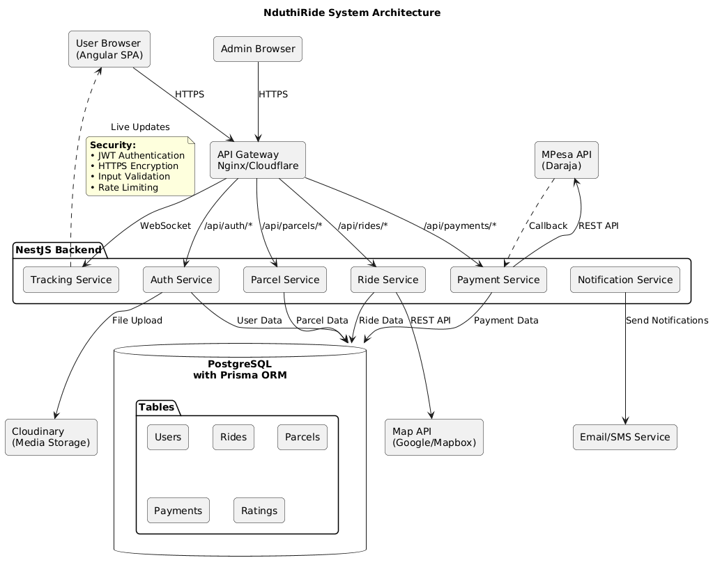
Figure 1:System Architecture Components Diagram

4.2 Database Design: The Hybrid Operational-Transactional Model
The database schema is designed to support high-volume transactional operations (creating rides, updating statuses) while maintaining complex relationships for reporting and user history.

4.2.1 Core Entity-Relationship Structure
The design centers on the `User`, `Rider`, `Ride`, and `Parcel` entities. `User` and `Rider` extend a base `Account` entity (containing auth details). A `Rider` has additional attributes like `licenseNumber`, `bikeRegistration`, and `isAvailable`. A `Ride` is created by a `User` and assigned to a `Rider`. It contains `pickupLocation`, `dropoffLocation`, `fare`, `status`, and timestamps. A `Parcel` is similar but includes `itemDescription`, `senderNotes`, and links to `senderId` (User) and `recipient` details (which could be a non-user).`Rating` entities are linked to both a `Ride`/`Parcel` and the involved `User`/`Rider`.

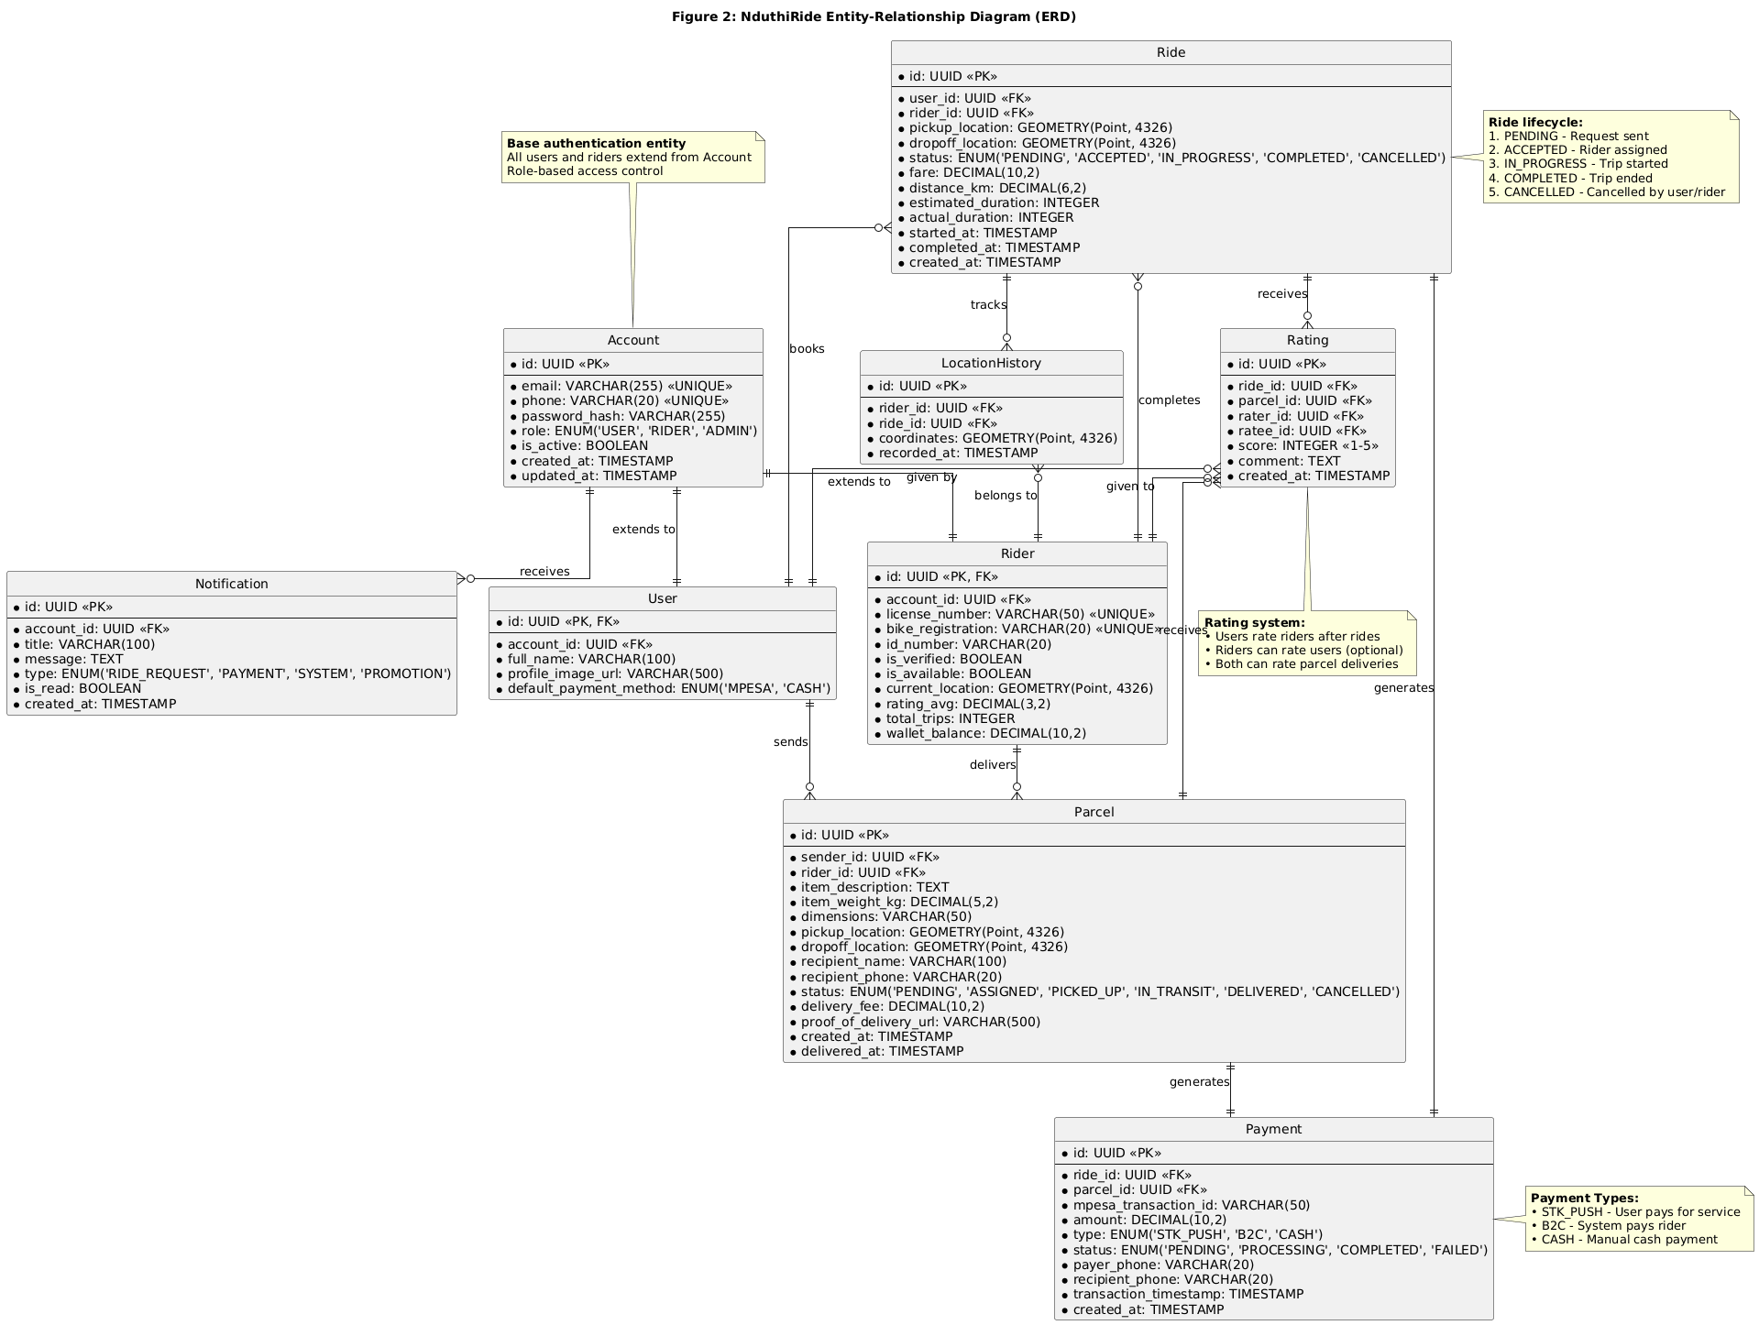
Figure 2:ER Diagram

4.2.2 Supporting Real-time and Analytical Needs
- Transactional Performance: Tables like `Rides` and `Parcels` are optimized for frequent `INSERT` and `UPDATE` operations (status changes). Indexes are placed on foreign keys (`userId`, `riderId`) and status columns for fast querying.
- Historical Analysis: For future reporting on rider performance, popular routes, or earnings analytics, the schema supports complex `JOIN` queries across `Rides`, `Users`, and `Ratings`. Timestamp columns on all major tables enable time-series analysis.
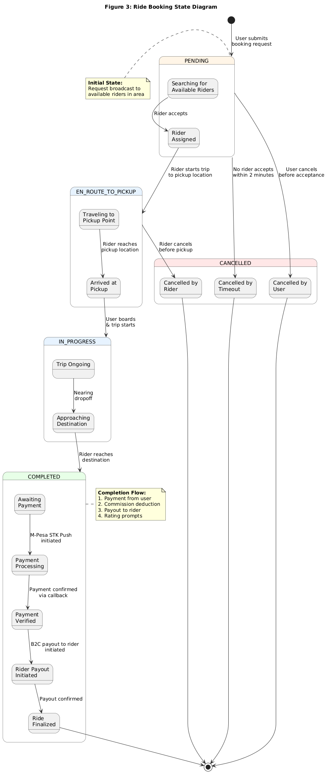
Figure 3:Ride Booking state diagram
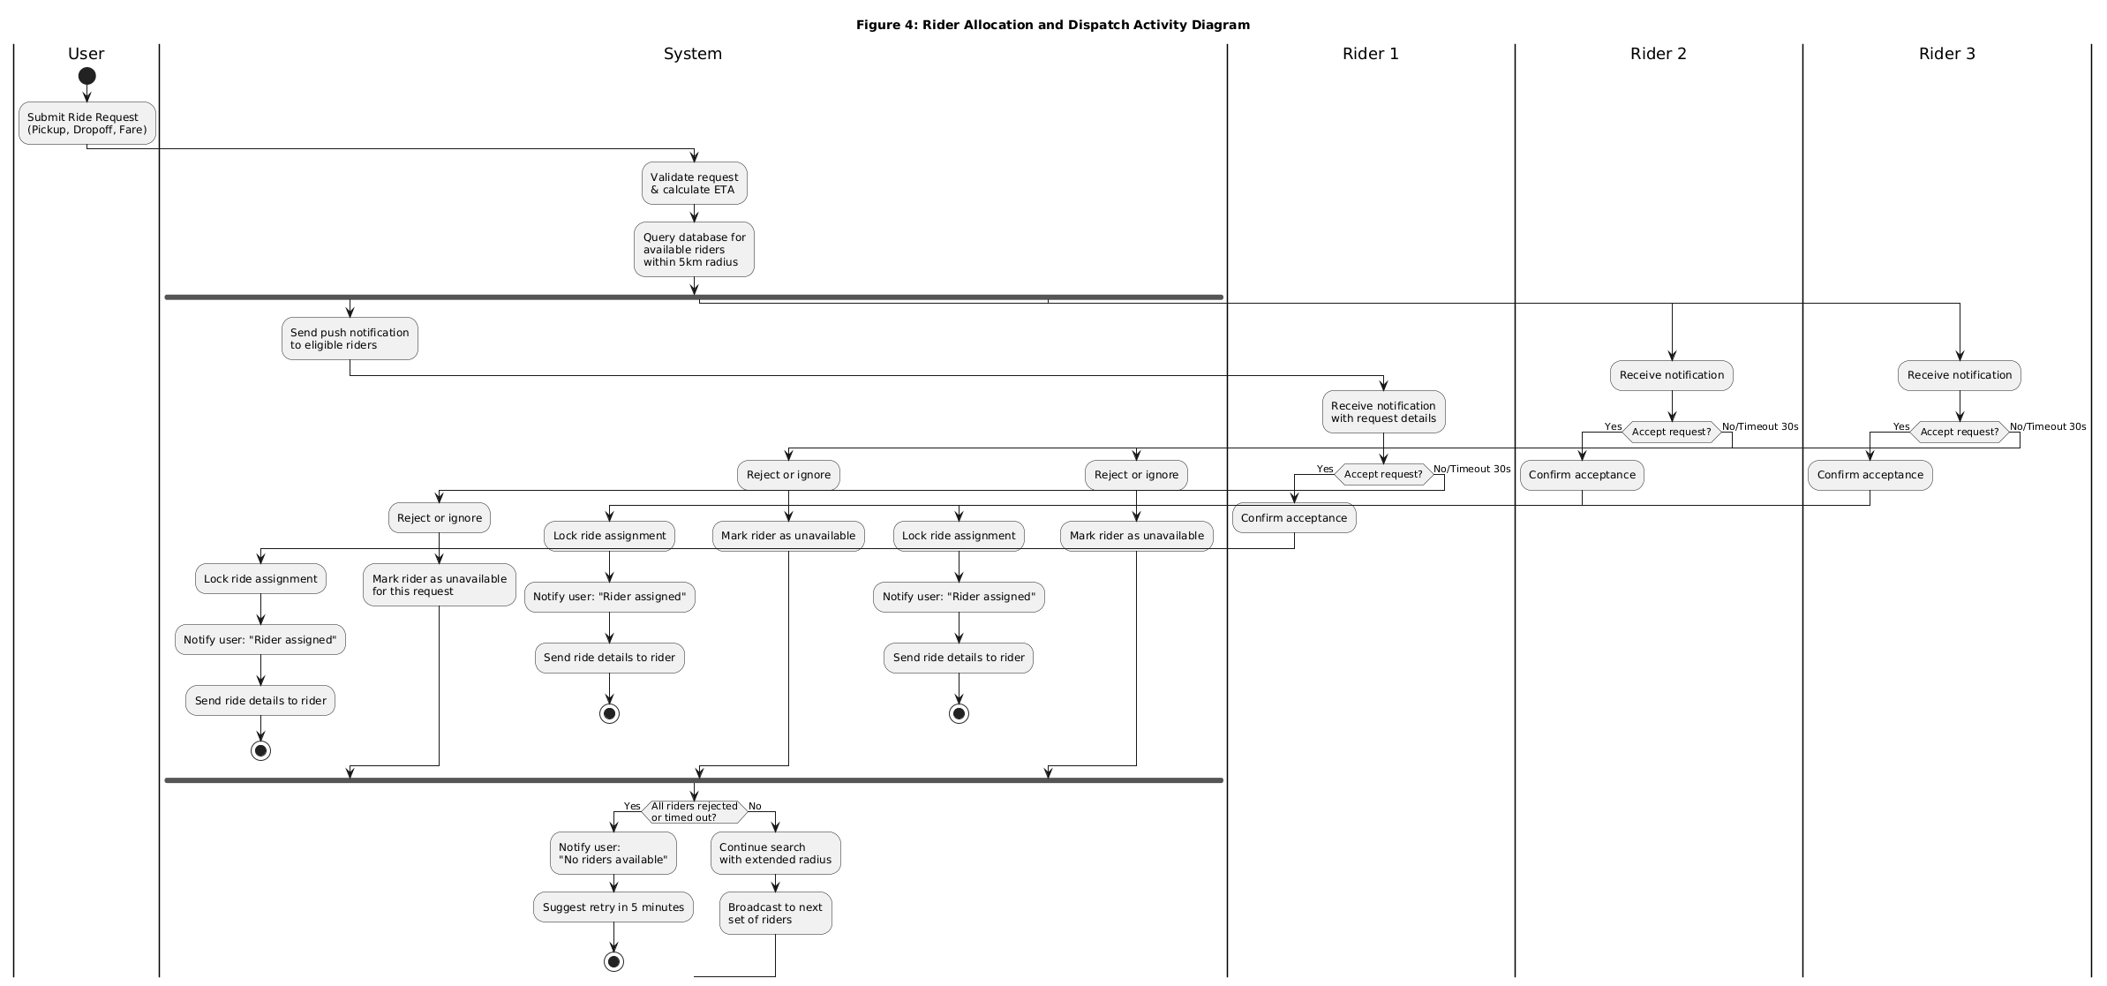
Figure 4:Ride allocation and dispatch activity diagram
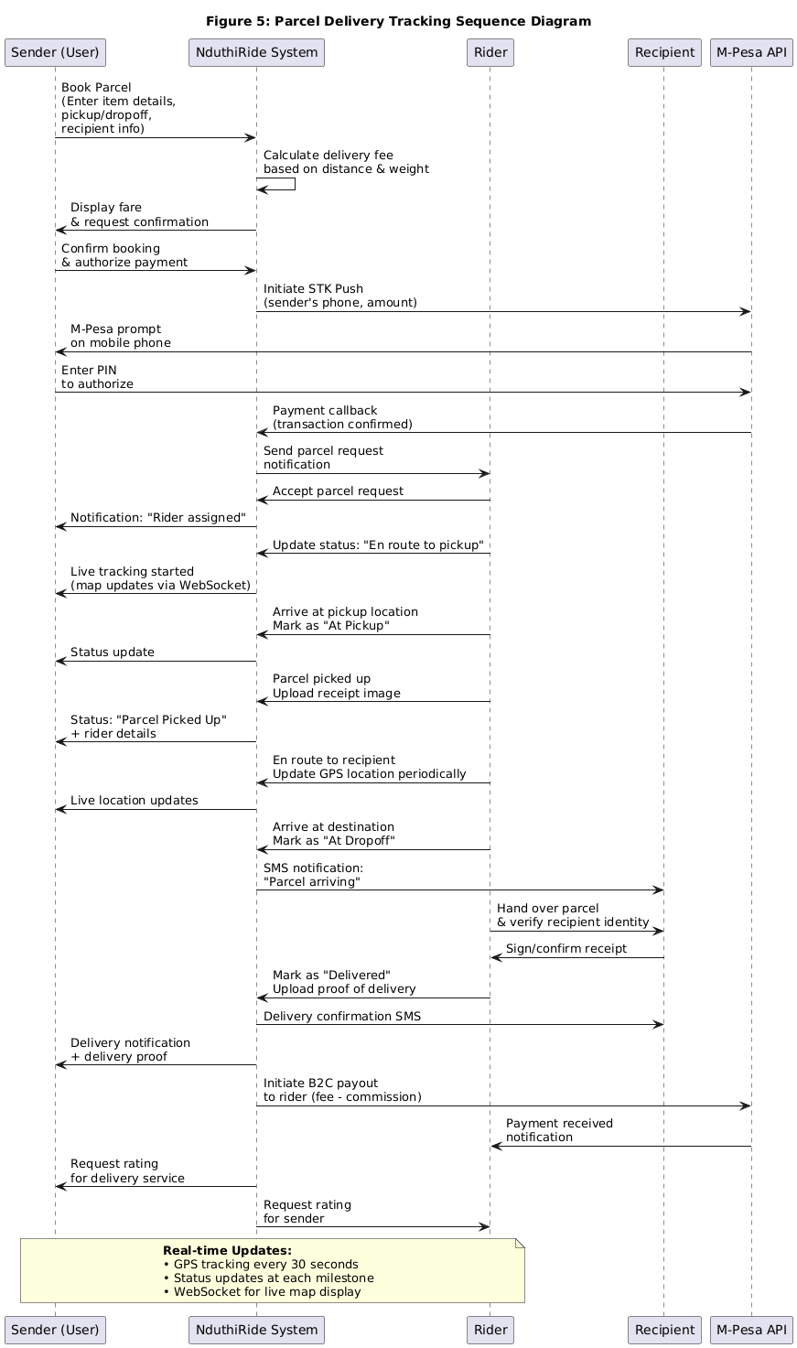
Figure 5:Parcel delivery sequence diagram
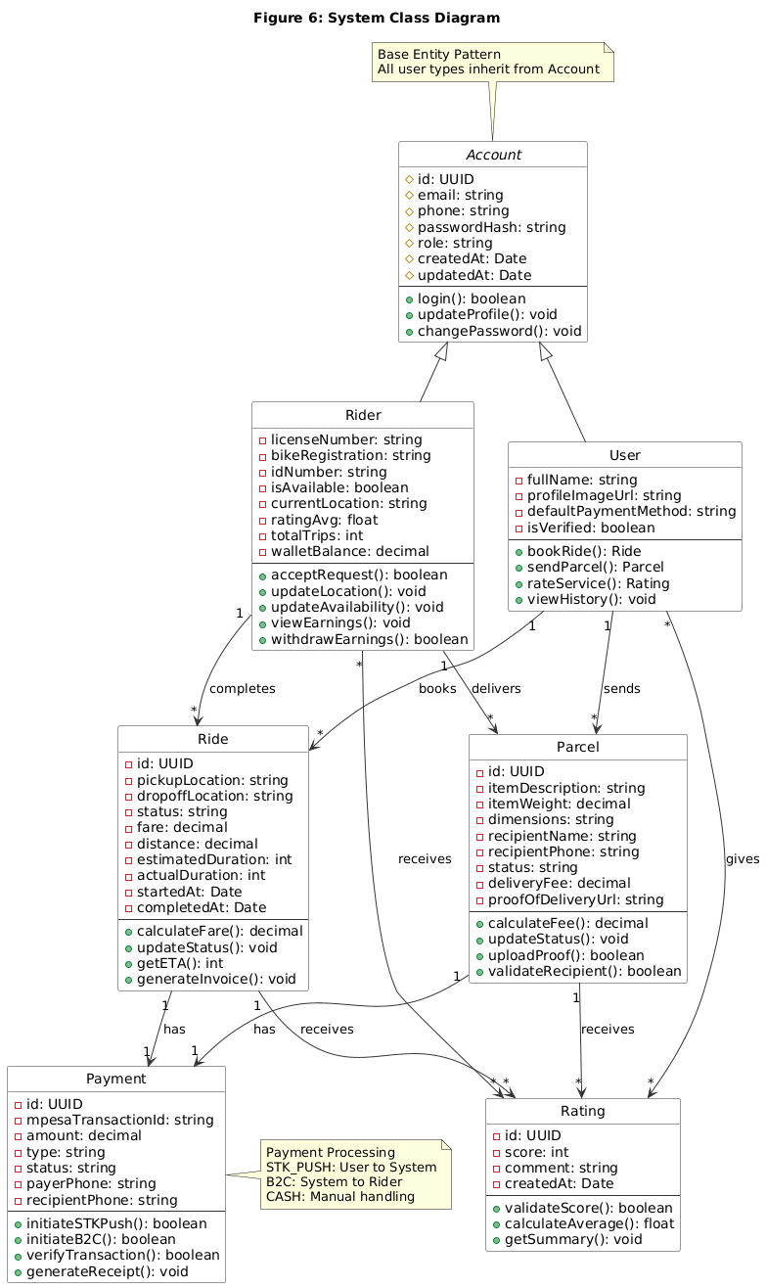
Figure 6:system class diagram
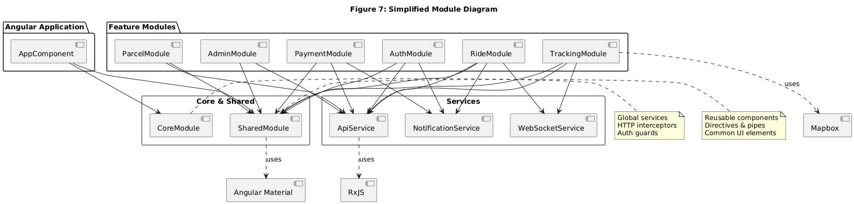
Figure 7:Simplified module diagram

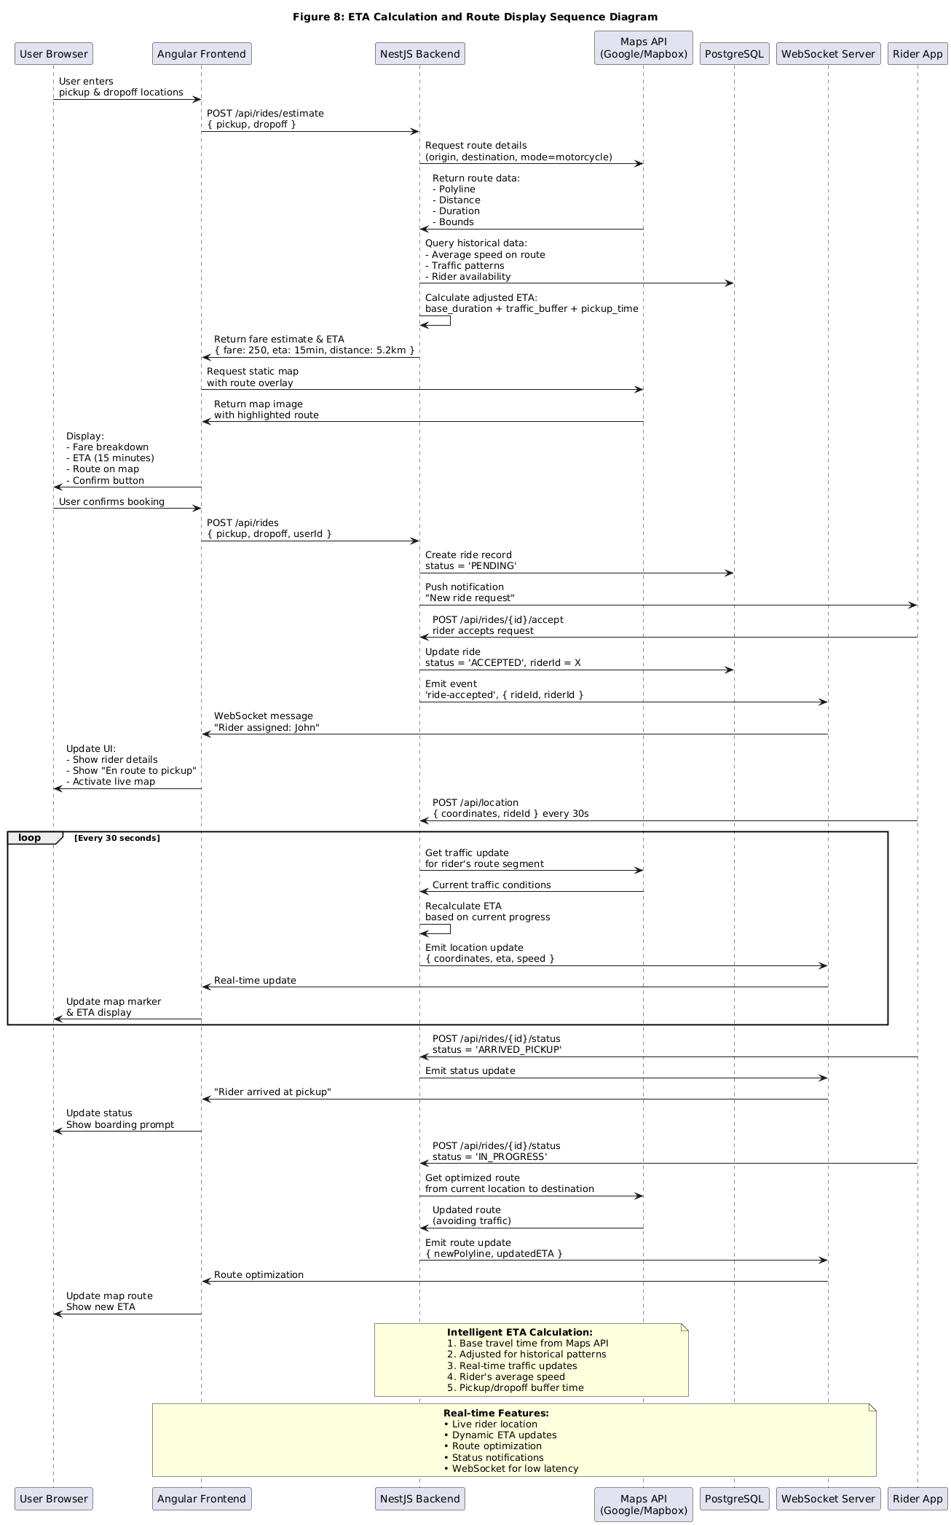
Figure 8:ETA Calculation and Route Display Sequence Diagram

4.3 Module Design Details
The system is decomposed into loosely coupled modules within the NestJS backend and Angular frontend.
- Authentication & Authorization Module (Auth):
  - Backend (`AuthModule`): Contains controllers for `/auth/login`, `/auth/register`. Uses Passport.js strategies (local, JWT) and Guards to protect routes. Services handle password hashing (bcrypt) and JWT token generation/verification.
  - Frontend: Provides login/register components, an authentication service to manage the JWT token (store in localStorage/sessionStorage), and an HTTP interceptor to attach the token to outgoing requests.
- Ride Management Module:
- Backend (`RidesModule`): Controllers for `/rides` (POST to book, GET to fetch user's rides). Services contain the core logic for fare estimation (based on distance from Map API), rider allocation algorithm (find nearest available rider with best rating), and status transition logic.
- Frontend: Components for ride booking form, ride history list, and active ride detail view with integrated map.
- Parcel Management Module:
- Backend (`ParcelsModule`): Similar structure to RidesModule but with controllers at `/parcels`. Services handle parcel-specific logic, such as validating item details and managing recipient information.
- Frontend: Components for parcel booking form and parcel tracking interface.
- Real-time Tracking Module:
- Backend: Establishes a WebSocket gateway (using `@nestjs/websockets`). Listens for location updates from the Rider app (simulated via Postman/Frontend in Phase I) and broadcasts them to the relevant user.
- Frontend: Connects to the WebSocket gateway. Upon receiving a ride/parcel assignment, listens for location events and updates the rider's marker on the map component (using Google Maps/Mapbox). Calculates and displays dynamic ETA.

- Payment Processing Module:
- Backend (PaymentsModule): Contains:
    - MpesaService: A dedicated service class encapsulating all Daraja API interactions (STK Push, B2C, transaction status queries).
    - PaymentController: Handles endpoints for initiating payments (POST /payments/stk-push) and receiving Safaricom's callbacks (POST /payments/callback).
    - Webhook Security: Implements validation of incoming callbacks using the Daraja API's signature verification to prevent fraudulent transactions.
    - Payment Reconciliation: Background jobs to check pending transactions and update their status periodically.
  - Frontend:
    - Payment Component: Displays fare breakdown and triggers STK Push when user confirms booking.
    - Payment Status Service: Polls backend for payment status updates and displays appropriate messages to user.
    - PayoutComponent (Rider Dashboard): Allows riders to view their earnings, payment history, and initiate payout requests if manual approval is implemented.

4.4 Scalability and Future Readiness Design
The architecture is designed with explicit extension points for Phase II and beyond.
- Microservices Preparedness: While monolithic in Phase I for simplicity, NestJS's modular design allows any module (e.g., `ParcelsModule`, `NotificationsModule`) to be easily extracted into a separate microservice in the future. Communication could shift to a message broker like RabbitMQ for resilience.
- Payment Gateway Integration: The `Ride` and `Parcel` entities have a `paymentMethod` and `paymentStatus` field. The backend service layer is designed with a strategy pattern in mind, where a `PaymentService` interface can have concrete implementations.
- IoT & Advanced Analytics: The database schema captures all necessary data points. Future IoT integration (real-time GPS pings from a rider app) would feed into a separate high-throughput data ingestion service. This service would write location trails to a time-series optimized table while publishing events for the main API to consume (e.g., "rider location updated"), keeping the core transactional database lean.

Chapter Five: Expected Outcomes, Project Schedule, and Conclusion

5.0 Expected Outcomes and Deliverables
Upon successful completion of project, the following tangible and intangible outcomes will be produced.
5.1 Software Deliverables (Working System)
- Fully Functional Web Application: A publicly accessible, mobile-responsive NduthiRide web application (Angular) allowing complete user and rider journeys for both rides and parcels.
- Robust Backend API: A fully documented, secure, and tested NestJS RESTful API deployed on a cloud platform, providing all necessary endpoints for the frontend.
- PostgreSQL Database: A populated and optimized database instance with the complete schema as designed, demonstrating data integrity and relational management.
- Source Code Repository: A well-structured, documented Git repository containing all frontend and backend source code, with a clear README for setup and installation.

5.2 Academic and Documentation Deliverables
- Project Proposal: This document, submitted for formal approval.
- System Design Documentation: Comprehensive documents detailing architecture, API specifications (using OpenAPI/Swagger generated from NestJS), database schema, and UML diagrams.
- Testing Report: Documented results of unit tests (Jest for backend, Karma/Jasmine for frontend), integration tests, and user acceptance testing (UAT).
- Final Project Report: A bound, comprehensive report encompassing all chapters of this proposal as executed, including results, challenges, and conclusions.
- Project Defense Presentation: A slide deck and live demonstration of the working system for the examination panel.

5.3 Project Schedule
A six-month Agile schedule broken into two-week sprints.

Table 3: Project Schedule (6-Month Agile Plan)
Month | Phase (Sprint Focus) | Key Activities | Deliverables / Milestones
Month 1 | Initiation & Planning | Finalize proposal, conduct user interviews, set up dev environment, create initial UI/UX mockups in Figma. | Approved Project Proposal; UI/UX Wireframes & Prototype.
Month 2 | Sprint 1 & 2: Core Backend & Database | Set up NestJS project, design & implement PostgreSQL schema with Prisma, build core `AuthModule` and `UsersModule`. Implement JWT/Passport.js. | Working Database & Prisma Client; Functional Authentication API (Register/Login).
Month 3 | Sprint 3 & 4: Business Logic & M-Pesa Integration | Implement RidesModule and ParcelsModule with complete business logic. Integrate Safaricom M-Pesa Daraja Sandbox API (implement STK Push for user payments, B2C for rider payouts, and callback handling). Develop payment reconciliation logic and transaction status management. | Core Booking APIs with complete M-Pesa Sandbox integration; All payment flows (user payment and rider payout) working in test environment.
Month 4 | Sprint 5 & 6: Frontend | Development Develop Angular components using Tailwind CSS for styling, implementing authentication, ride/parcel booking interfaces, and payment processing. Consume backend APIs. | Polished, responsive frontend connected to backend with modern UI/UX.
Month 5 | Sprint 7 & 8: Real-time Features & Polish | Implement WebSocket module for real-time tracking. Enhance UI with map integration for tracking. Implement rating system. Conduct comprehensive testing (unit, integration). | Beta System with Real-time Tracking. Comprehensive Test Report.
Month 6 | Sprint 9 & 10: Deployment & Documentation | Deploy frontend and backend to cloud platforms. Perform final UAT and bug fixes. Compile all documentation. Prepare final report and presentation. | Final Working System Deployed; Submission of Final Bound Report.

5.4 Conclusion and Future Work (Phase II Roadmap)

5.4.0 Conclusion
This proposal has outlined the design and implementation plan for NduthiRide, a smart ride and parcel delivery system tailored for Tharaka Nithi County. By addressing the critical gaps of inefficiency, lack of transparency, and service fragmentation in the current boda boda sector, the project aims to deliver tangible socio-economic benefits. The technical approach, leveraging Angular, NestJS, and PostgreSQL, is not only appropriate for building a robust Minimum Viable Product (MVP) but also establishes a scalable, maintainable architectural foundation. The adoption of Agile methodology and usability principles ensures the final product will be both technically sound and user-centric. This project represents a meaningful application of computer science principles to a real-world local problem, contributing to the digital transformation of the informal transport sector.

5.4.1 Future Work (Phase II Roadmap)
Phase I establishes a complete, functional platform with cashless payments. Phase II would focus on enhancement, scalability, and commercialization:
- Mobile Application Development: Build dedicated Android and iOS applications using Flutter or React Native for a more native user and rider experience, including background location tracking for riders.
- Advanced M-Pesa Features: Implement additional payment flows like split payments, scheduled payouts, and integration with M-Pesa Business Till numbers for corporate clients.
- AI/ML Features: Implement machine learning models for dynamic pricing based on demand and supply, predictive ETAs using historical traffic patterns, and fraud detection in payments or ratings.
- Expanded Logistics: Introduce features for scheduled deliveries, multi-stop trips for riders, subscription models for frequent users, and business accounts for commercial senders.

Bibliography
Mogire, E., Kilbourn, P. J., & Luke, R. (2023). Customer satisfaction with last-mile delivery in Kenya: An online customer perspective. Journal of Transport and Supply Chain Management, 17, a844. https://doi.org/10.4102/jtscm.v17i0.844
Munyasya, C. K., & Gudda, K. O. (2025). Implication of mobility solutions and technological advancement for third-party logistics providers (3PLs) in Kenya. EPRA International Journal of Multidisciplinary Research (IJMR). https://doi.org/10.36713/epra23618
Mogire, E., Kilbourn, P. J., & Luke, R. (2025). Electric vehicles in last-mile delivery: A bibliometric review. World Electric Vehicle Journal, 16(1), 52. https://doi.org/10.3390/wevj16010052
Communications Authority of Kenya. (2025). Mobile, Data and Digital Services on the Rise, CA Report Shows. Retrieved from https://www.ca.go.ke/statistics
Safaricom PLC. (2025). Daraja 3.0 API Documentation. Retrieved from https://developer.safaricom.co.ke

